Networking Simulation (Cisco Packet Tracer)
Lab Objective
My task was to build a small, secure enterprise network in Cisco Packet Tracer for three departments (Admin, Sales, IT). Each department must be on its own VLAN and subnet. I needed to implement VLAN segmentation, configure inter-VLAN routing using Router-on-a-Stick and then apply access control lists (ACLs) to restrict unauthorized access between departments so Admin can only access Sales (not IT), Sales can access IT (not Admin), and IT has unrestricted access. I also secured device management via secure remote access (SSH) and disabled insecure protocols like Telnet to improve network security. Documented below are commands, test evidence, and troubleshooting steps.
- Network Topology Design
The network topology I used in my design consisted 1 Copper Straight-through to connect the different types of network devices, 1 Router 2911, 1 Switch 2960, and 3 end devices (PCs) representing the Admin, Sales, and IT departments.
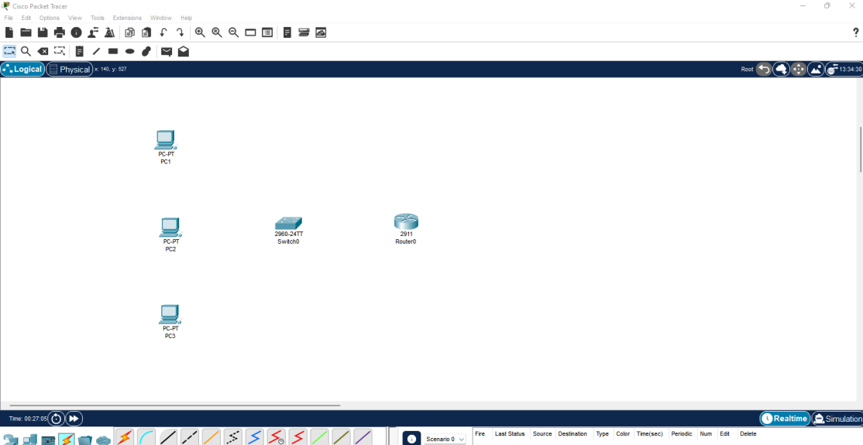

- VLAN Segmentation
My next step was to create the logical segmentation required for network security. I created three VLANs on the switch and configured the necessary access ports. For example, to set up the Admin VLAN (VLAN 10), I used the commands “Switch(config)# vlan 10” and “Switch(config-vlan)# name Admin”. I then assigned the appropriate switch ports to these new VLANs and set them to access mode. Finally, I configured the link connected to the router as a trunk port using the switchport mode trunk command “Switch(config)# interface gig0/1” “Switch(config-if)# switchport mode trunk”, which allows traffic from all three VLANs to travel across that single physical link.

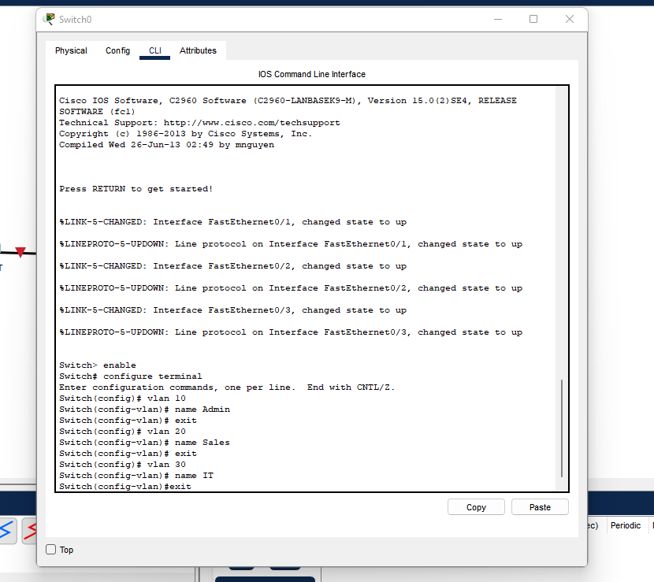

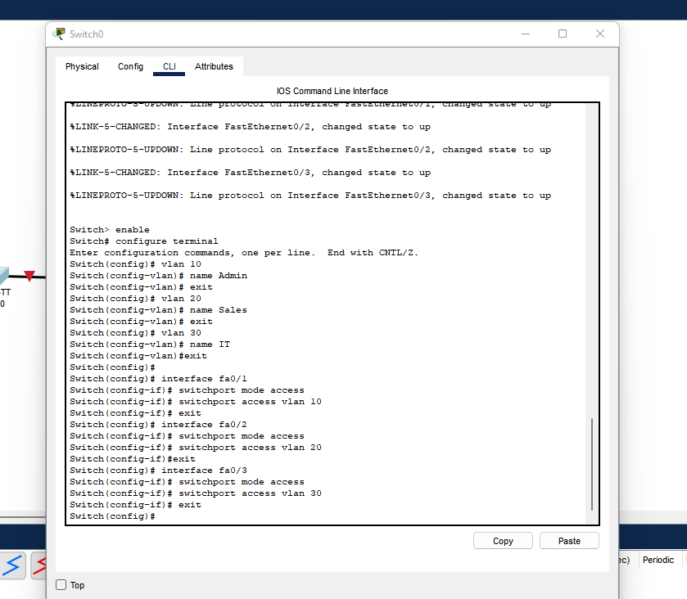

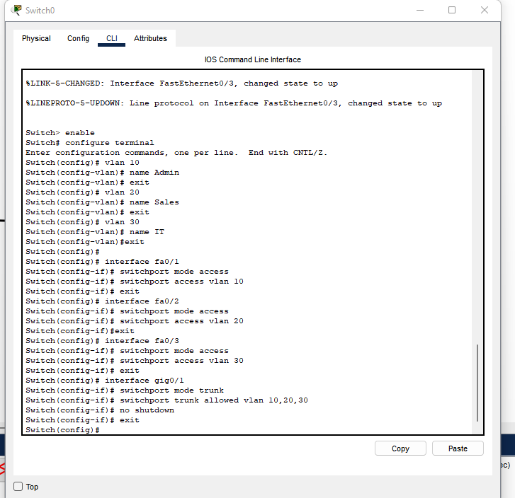

Department | VLAN ID | Network Address | Gateway (Router Subinterface)
Admin | 10 | 192.168.10.0/24 | 192.168.10.1
Sales | 20 | 192.168.20.0/24 | 192.168.20.1
IT | 30 | 192.168.30.0/24 | 192.168.30.1

- Inter-VLAN Routing
With the switch configured, I moved to the router to enable inter-VLAN routing. Since the ROAS method uses one physical interface to route multiple logical networks, I created three separate sub-interfaces on the Router's GigabitEthernet0/0 port—one for each VLAN. For the Admin VLAN, I entered “Router(config)# interface GigabitEthernet0/0.10”, used the “encapsulation dot1Q 10” command to specify the VLAN tag, and then assigned the SVI gateway IP address, such as “ip address 192.168.10.1 255.255.255.0”. I repeated this process for the other two VLANs, effectively turning the router into the Layer 3 traffic cop that could now route packets between the segmented VLANs.
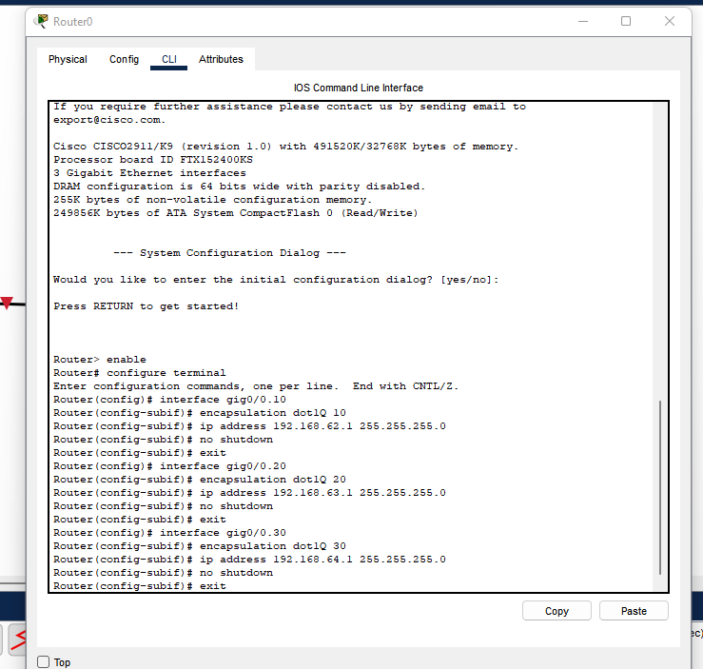

PC1 | PC2 | PC3
IPV4 --> 192.168.62.10 | IPV4 --> 192.168.63.10 | IPV4 --> 192.168.64.10
Default gateway --> 192.168.62.1 | Default gateway--> 192.168.63.1 | Default gateway --> 192.168.64.1
Subnet mask --> 255.255.255.0 | Subnet mask --> 255.255.255.0 | Subnet mask --> 255.255.255.0

- Access Control Lists (ACLs)
Next, I implemented Extended Access Control Lists (ACLs) to restrict communication according to the company's security policy. I created standard ACLs to govern which VLANs could communicate. ACLs are sequential, so the rule permitting traffic (e.g., Admin → Sales) had to be placed immediately before any rule denying traffic (e.g., Admin → IT), followed by an explicit “permit ip any any” statement to ensure all other traffic not explicitly denied by the previous rules was allowed through. I deliberately did not apply an ACL to the IT VLAN (VLAN 30), allowing its communication to remain unrestricted per policy. After defining these rules, I applied the ACLs on the respective router sub-interfaces using the appropriate ip access-group commands. I encountered an error when verifying connectivity because, in the application command for the Admin VLAN, I mistyped the ACL name, using "ACL_ADMIN" instead of the correct "ip access-group ADMIN_ACL." To troubleshoot and verify, I first checked the existing rules with the command “show access-lists” on the router, which allowed me to confirm what was saved. I then made the necessary corrections and performed another set of ping tests to confirm that the security rules were working as intended.
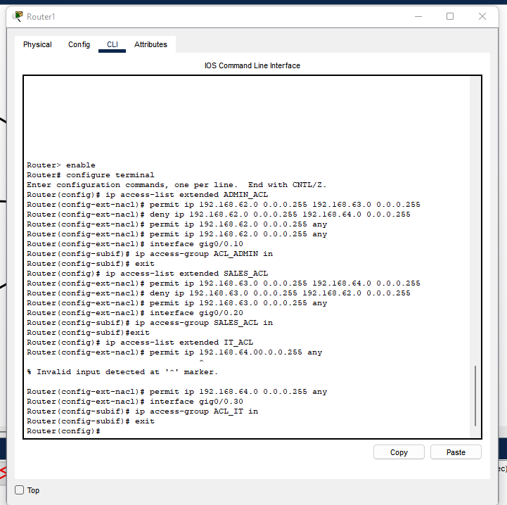
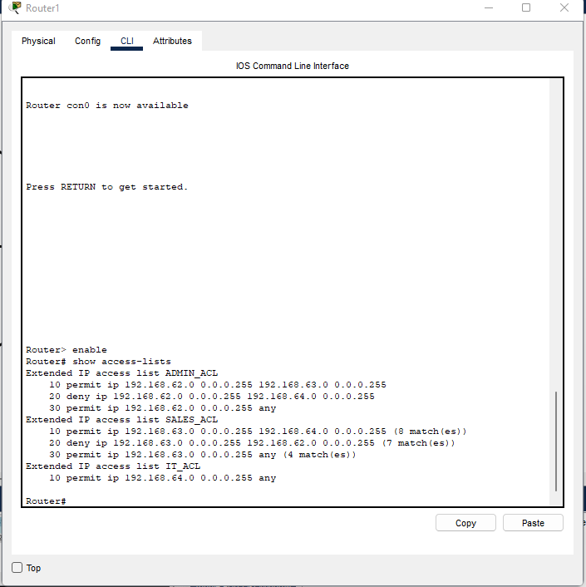

- Security Justification
The ACLs implemented follow the Principle of Least Privilege (PoLP), ensuring that each department only has access necessary for its operations:
- The Admin VLAN is restricted to prevent exposure of sensitive HR/Finance data to IT staff.
- The Sales VLAN is limited to access IT support systems but cannot view Admin resources.
- The IT VLAN retains full access to all segments to maintain and troubleshoot the network.
By controlling inter-VLAN communication, the design minimizes internal attack surfaces and unauthorized data access.
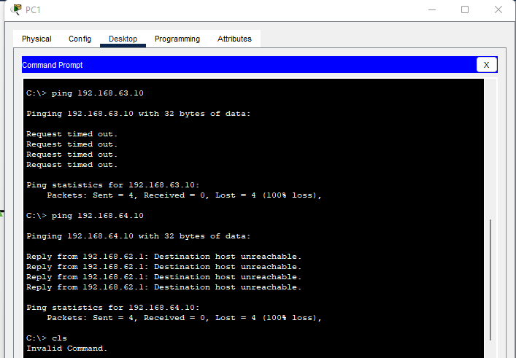
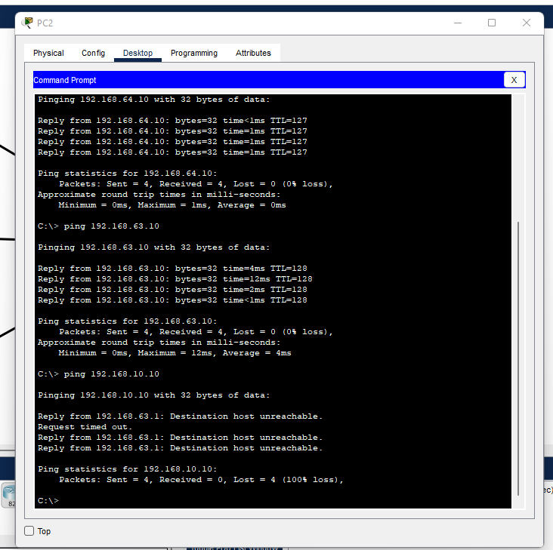

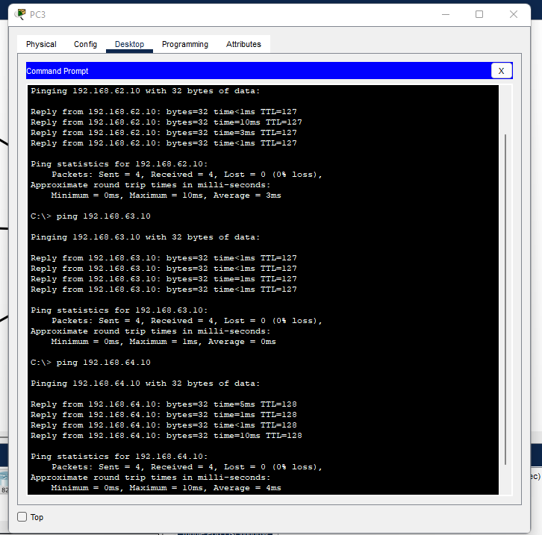

- SSH Configuration (Secure Remote Access)
- On Router
The final security measure involved protecting remote management access . To ensure all remote connections used encrypted channels, I configured Secure Shell (SSH) and simultaneously disabled Telnet, preventing unencrypted authentication. This process involved several steps:
First, I configured the router hostname and domain name, then I generated the required RSA keys. I also created a local user account for authentication.
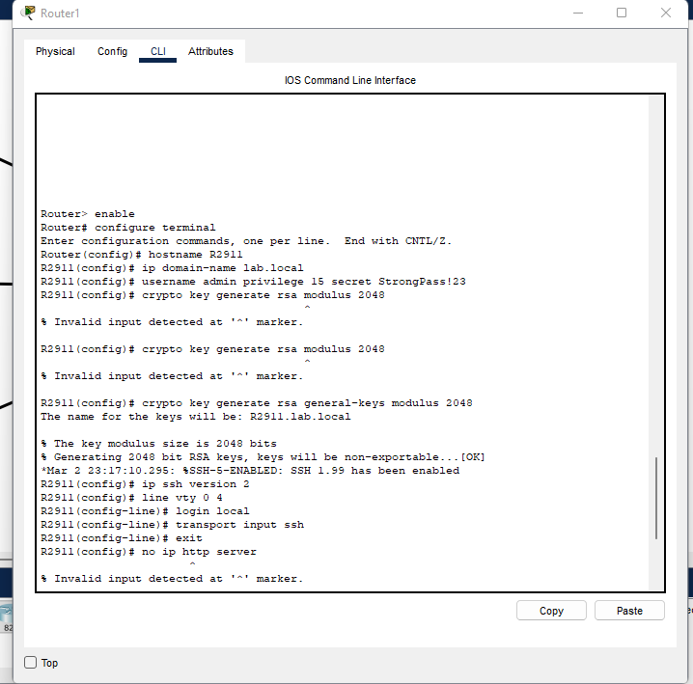

- On Switch
Secure Shell (SSH) is the industry standard for this task because it inherently encrypts all data transmitted between the administrator and the switch, including usernames, passwords, and configuration commands. I began the configuration by establishing the basic identity of the device, setting the switch hostname to “R2911” and configuring the domain name, lab.local. These are essential prerequisites required by the system to generate the necessary cryptographic keys for SSH encryption.
The critical step for enforcing PoLP was the creation of a unique local administrative account using the command username admin privilege 15 secret StrongPass!23. This action creates a local administrative account, admin, which is a cornerstone of PoLP as it establishes accountability, every configuration change is tied to this specific user. By assigning privilege 15, I grant the account full administrative rights, but I ensure that this access is strictly controlled by a dedicated, strong, encrypted secret password, overriding any reliance on a generic, shared "enable" password.
To enable secure communication, I proceeded to generate the cryptographic keys, executing the command crypto key generate rsa general-keys modulus 2048. The security rationale here centers on Data Protection; the command generates a robust, 2048-bit RSA key pair which is used to establish the encrypted SSH tunnel, protecting all subsequent management traffic from interception.
The final, crucial step was locking down the Virtual Terminal (VTY) lines, the channels used for remote CLI connections. I applied the security policy across all VTY lines (line vty 0 15) and immediately ran the command transport input ssh. This is a fundamental security measure as it explicitly disables the insecure Telnet protocol, forcing all remote management connections to utilize SSH only. To further support PoLP and session control, I implemented login local, ensuring only authenticated, accountable local usernames can log in.
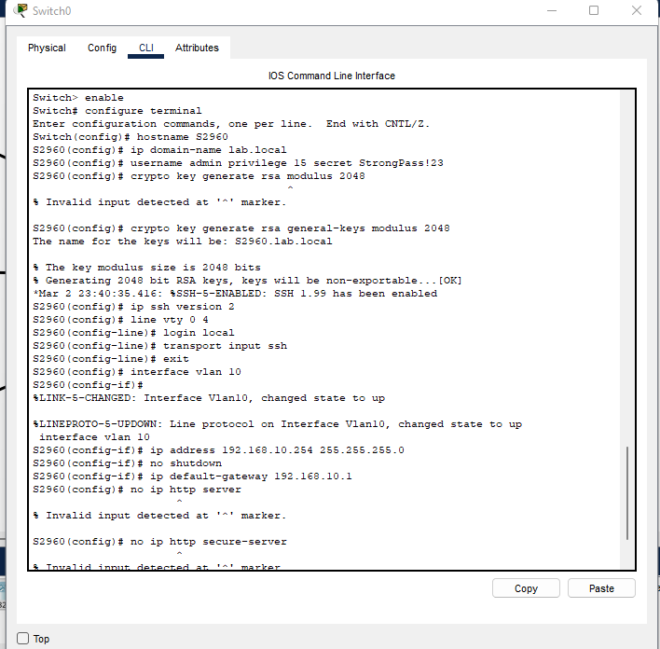

5. Testing and Verification
- I used the command “show vlan brief” on the switch to verify the VLANs connections.
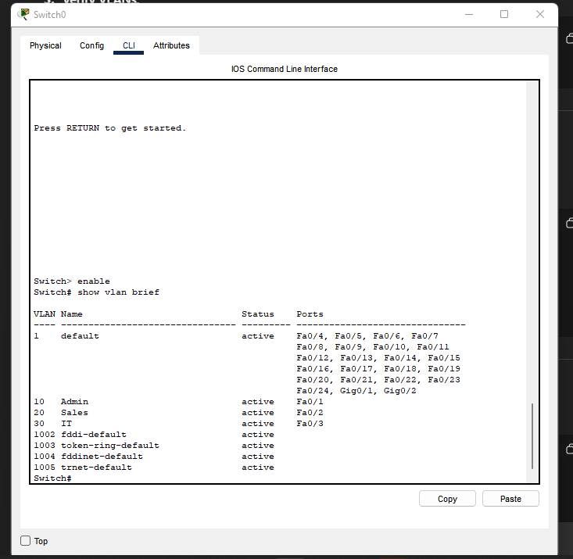

- To confirm inter-VLAN routing was working before ACLs, from any PC I used Desktop → Command Prompt. All gateways responded then I pinged PC to PC (e.g., Admin → Sales) to confirm routing. I verified connectivity with ping between VLANs.
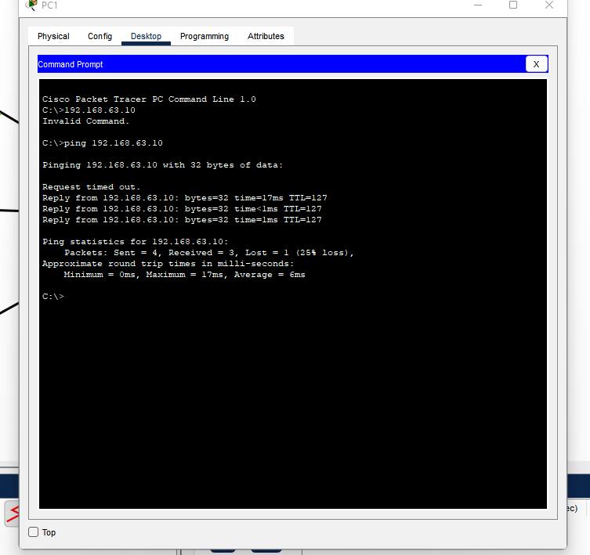
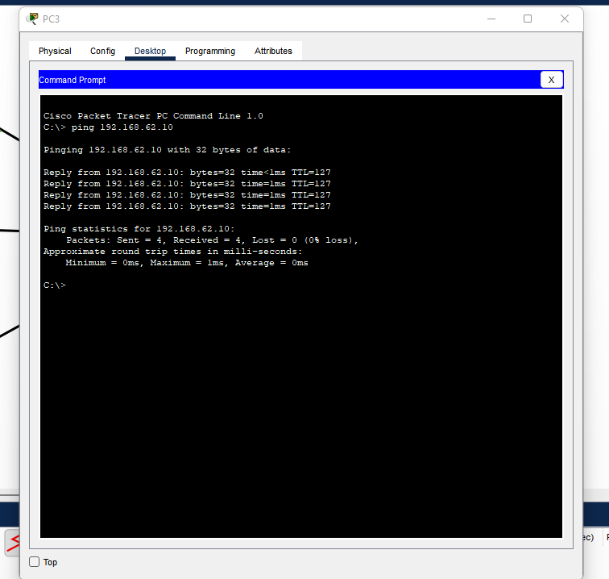

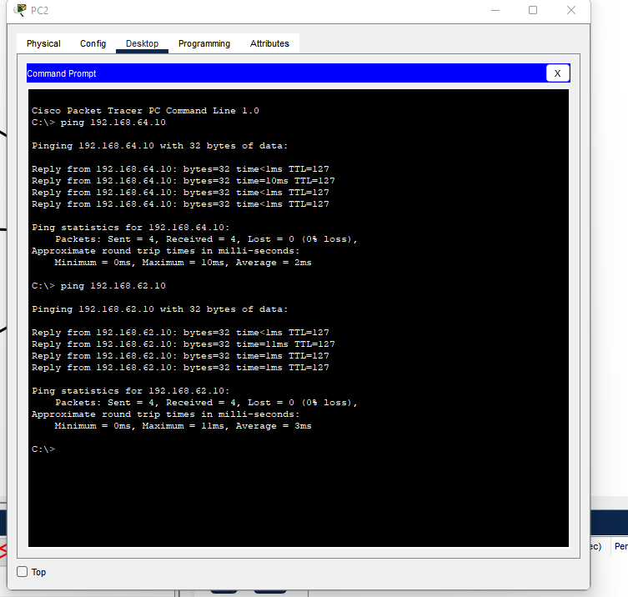

- I verified the subinterfaces with the command “Router# show ip interface brief”.
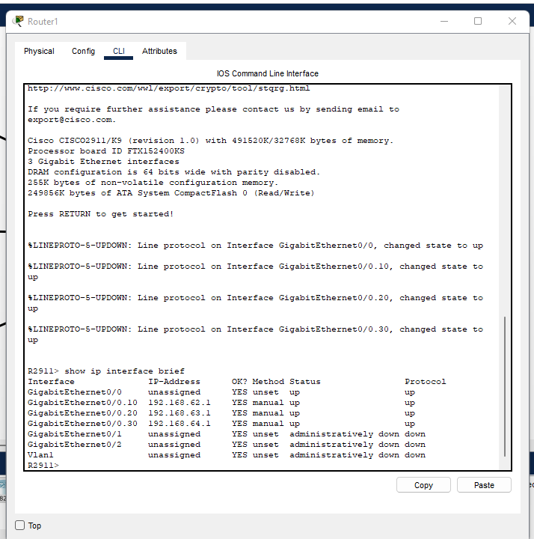

- I used the transport input ssh command to explicitly enable SSH and disable Telnet access. I verified that SSH was active by successfully connecting from a client PC using the SSH client, by executing the command “ssh -l admin 192.168.10.1.” confirming that management access was both successful and secure via encryption. I tested the ACL by trying to ping from PC_Admin to PC_Sales (failed as expected). Telnet access was tested and correctly denied.
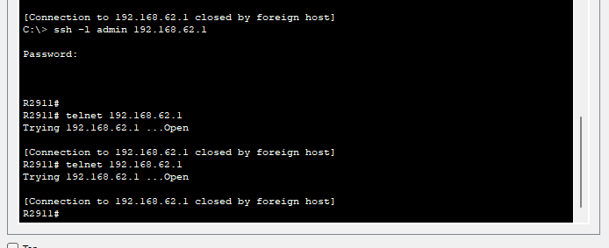

6. Security Implications of Misconfiguration
If VLANs or ACLs were misconfigured:
- Devices could bypass departmental restrictions, leading to data leakage.
- If SSH was not enforced and Telnet left enabled, attackers could capture credentials in plaintext.
- An incorrect trunk setup could cause VLAN hopping attacks.
- Wrong ACL order could inadvertently block legitimate traffic, disrupting operations.

7. Tools and Applications Used
- Cisco Packet Tracer – for topology design and configuration
- VMware Workstation – for hosting virtualized networking labs
- Command Line Interface (CLI) – for manual configuration and verification

Conclusion
In this lab, I successfully created a segmented and secure small office network using Cisco Packet Tracer. By implementing VLANs, inter-VLAN routing, ACLs, and SSH, I ensured that each simulated department could operate independently with controlled access. This configuration strengthened the overall network security posture, maintained operational efficiency, and effectively demonstrated the key principles of network segmentation and least privilege.
This project allowed me to practically apply core concepts in network design, VLAN segmentation, inter-VLAN routing, and access control implementation. Specifically, I successfully built a secure multi-VLAN network and configured a Router-on-a-Stick setup to handle the routing between these segregated subnets. I enforced department-level access control with Access Control Lists (ACLs) and secured device management by configuring SSH. Finally, I verified full network functionality through comprehensive ping and connectivity tests, ensuring all requirements were met.
I completed the lab with a fully working Router-on-a-Stick configuration and ACLs that precisely enforced the required department policies. Configuring SSH for secure management was straightforward, and I documented all commands, screenshots, and testing evidence for the final submission. The most significant learning moment during this process was understanding how critical ACL order and placement are; a misplaced or incorrectly ordered rule can either fail to enforce security or accidentally break necessary connectivity. This experience reinforced the practical, step-by-step methodology required to successfully build and secure an inter-VLAN environment.
Overall, this exercise deepened my understanding of how logical segmentation and access control combine to create a robust and secure enterprise network. I now feel confident reproducing this lab on real devices with the knowledge necessary to apply an appropriate production-hardened setup.

